

Group No: 21301

Group members:
Helianthus Collector

Key Words: Collection – Parabola – Mass Flow Rate – Tracing

Obour STEM school
Grade 12, Semester 1, 2021/2022

-Youssef Ahmed
-Mohamed Haitham
-Ramy Said

Abstract:
From the difficulties confronting and endangering Egypt's future is incomplete reliance on alternative energy resources, as the most fundamental source of generating electricity today is the combustion of fossil fuels, which results in dangerous consequences such as pollution of the atmosphere by emitting greenhouse gases, which affects public health issues; thus, the purpose of the current capstone project is to use alternative energy and connect it technologically.
Due to the non-well exploitation of the sunlight, the selected solution is concluded in getting the maximum benefit from the thermal energy coming from the sun, which will produce a tremendous amount of power if exploited perfectly. The parabolic trough will collect the sun's rays. The system is developed as a closed system in storing heat energy. The system will be triggered automatically by a stepper motor connected with Arduino; to trace the sun's position in the daylight to increase efficiency. Consequently, after the water passes from the collector's pipe, the water would store in the container. After settling in the container towards the collector, it will be pumped again manually by the water pump to ensure that the fluid will not cool down. The used fluid was water in the test plan, following safety precautions. It achieved a difference of 10 degrees per seven minutes at a temperature of 17°C, with total heat energy of 28980 joules.
By investigating the test plan results, the solution could achieve the chosen design requirements by calculating the mass flow rate to determine the velocity of the fluid correlates with the area of the pipe, and the whole system achieved a total efficiency ranging from 50% to 70% means that would be able to be applied in real life.
Introduction:
Nowadays, Egypt is facing a problem in the alternative energy overall because of many reasons starting with the persistent increase in the population, which increases the demand for every commodity that also needs a stable source of energy, but coal, natural gas, and oil all can run-up. Although fossil fuel is deemed an unrenewable source of energy, it also leads to many dangerous consequences like pollution in the atmosphere by emitting greenhouse gases and public health issues. Fossil fuel is considered not friendly to the environment as it pollutes. There are large abundance regions of unexploited resources in the arid areas with a large amount of sun rays and wind that could be recognized in the production or storage of this type of energy. Remarkably, the deployment of alternative energy is the best solution to the current problem.
So, the current capstone challenge targets the communication and clean energy production, storing, or distribution, matching Egypt’s vision by 2030 for an affordable and clean energy source by exploiting the sun, wind, and hydroelectric power. Many prior solutions have been applied in Egypt and other countries in the field of communication and energy like the smart grids and other systems which are responsible for triggering alternative energy facilities, distributing the outcome energy to the customer, storing the over-limit energy, and reducing electricity losses in transmission, distribution with low costs for the client. However, the cost for such stations was high, and the latency period usually takes up much time, continuous need for maintenance, and also facing a high risk of being hacked. After analyzing the strengths and weaknesses of prior solutions, it was concluded that system security, appliance cost, and dependability or efficiency of the solution were the most critical requirements that needed to be addressed.
Consequently, according to all of these data and the extensive investigation into various methods, the current solution was chosen in terms of its efficiency, form, and its application, so the parabolic trough will be done in minor heat storage in a closed system that would be applied by adding a reflecting plate that depends on the reflection of the sun rays on a tube containing fluid, so the fluid will be heated and stored in containers then pumped to the tube. The idea would occur by applying communication methods

Materials and Methods:
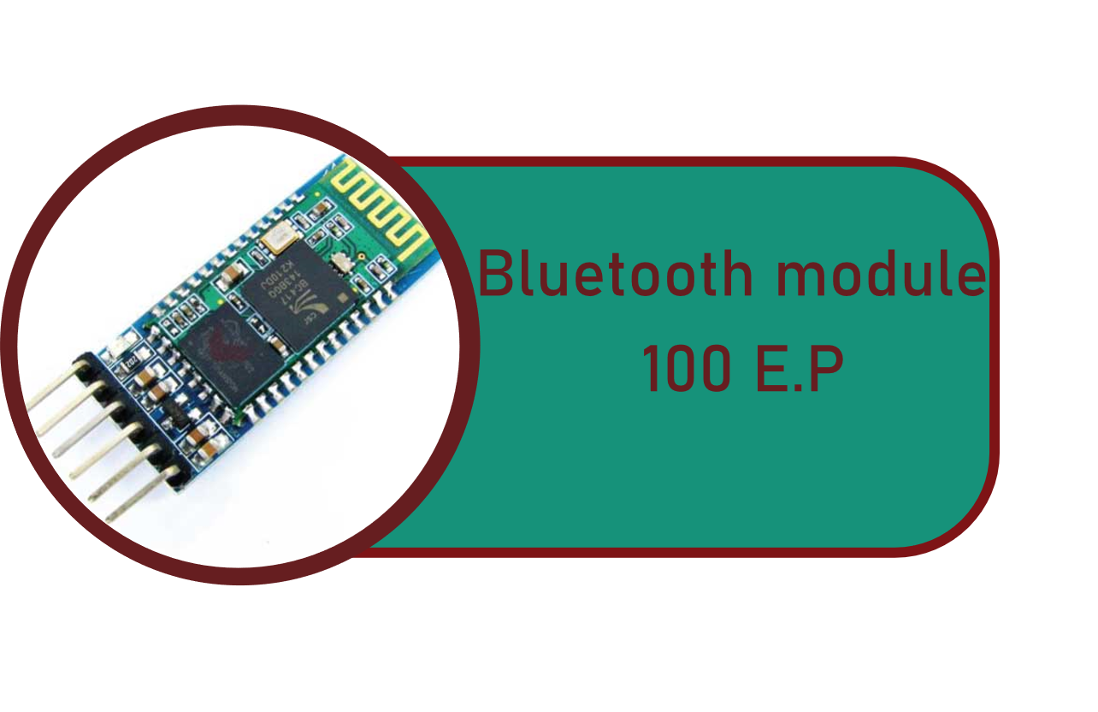
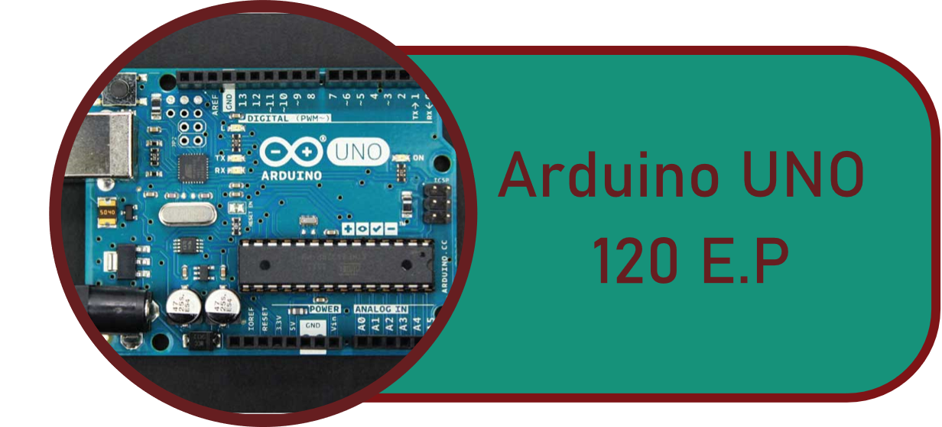
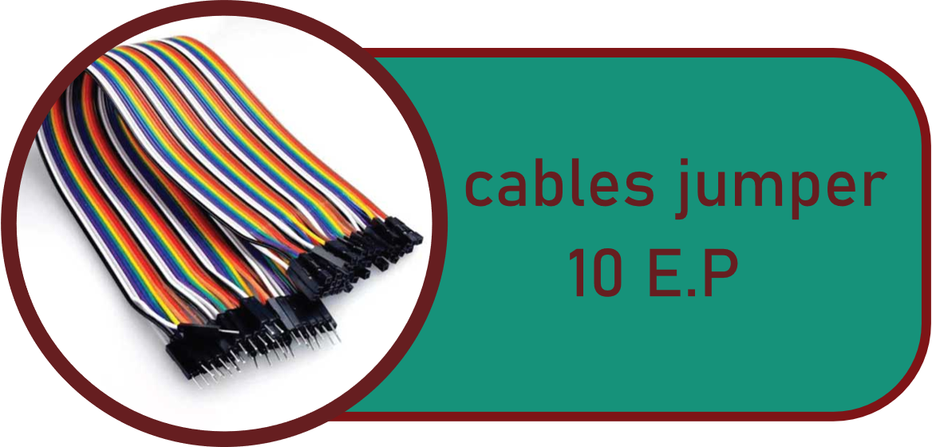
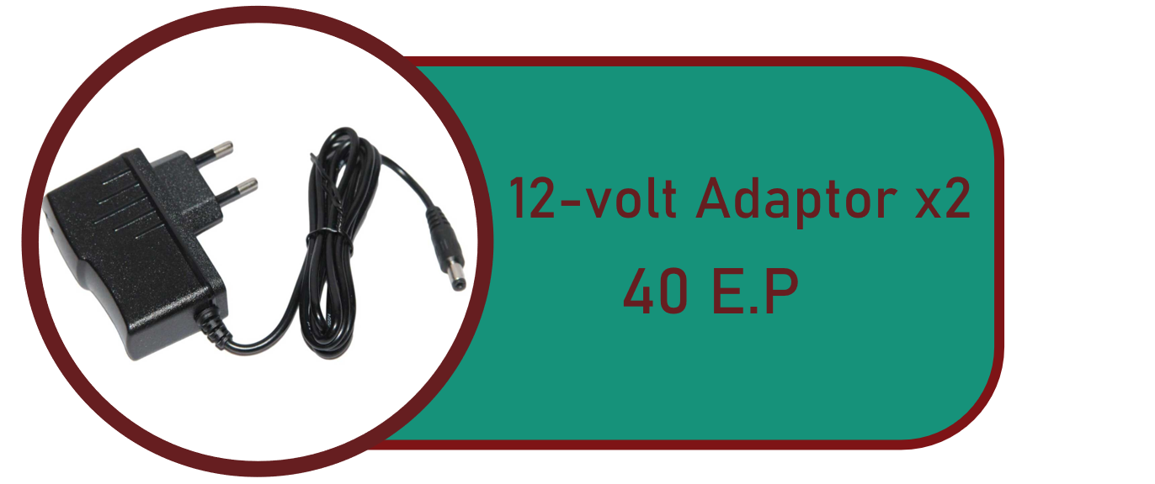
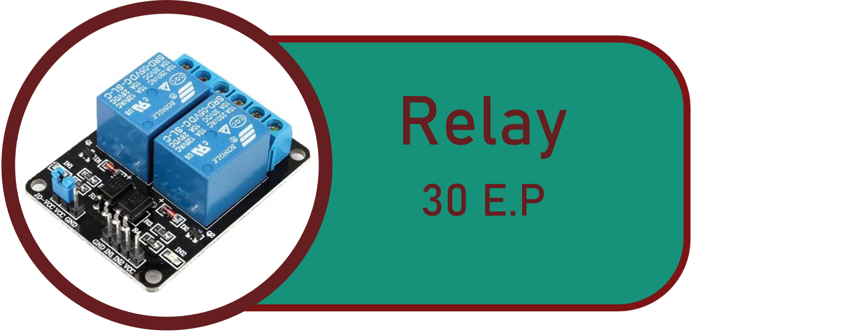
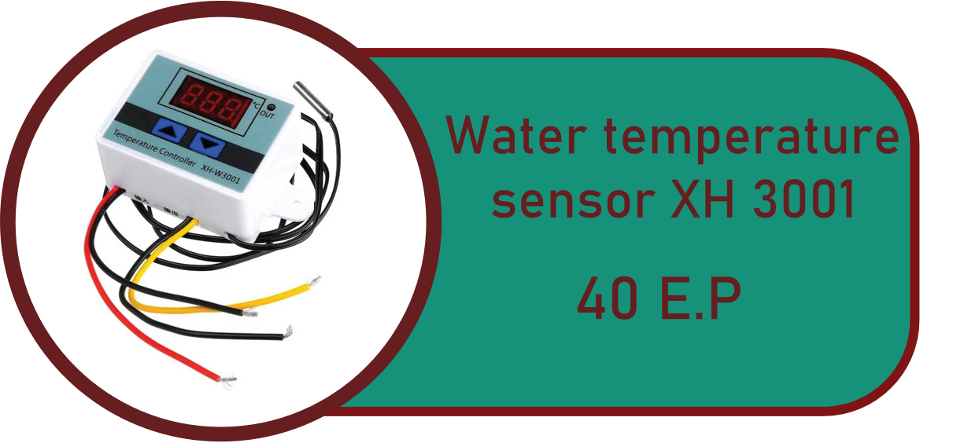
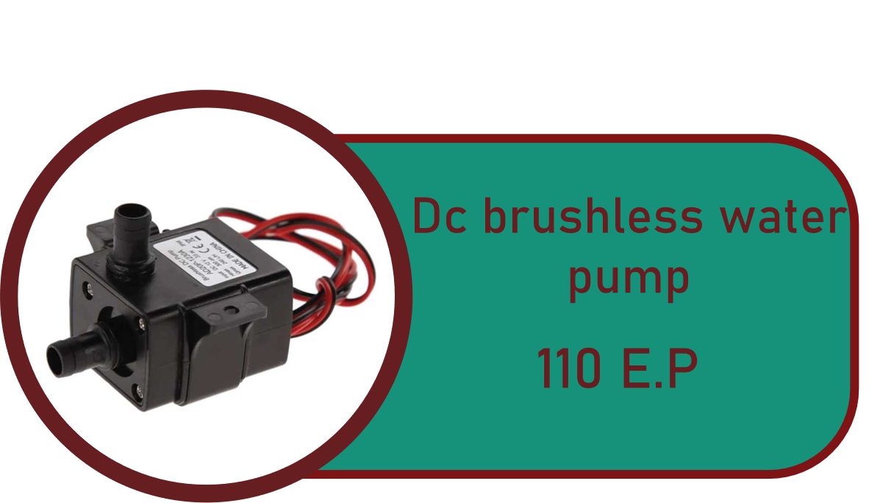
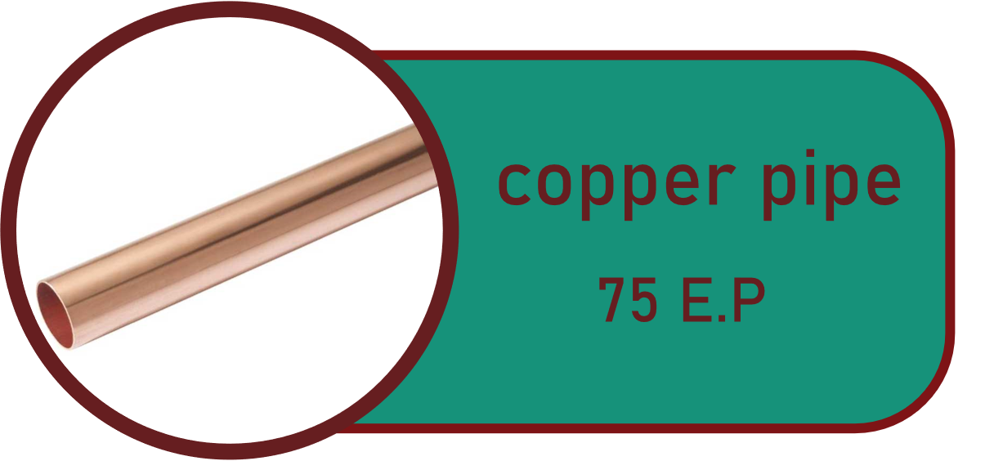
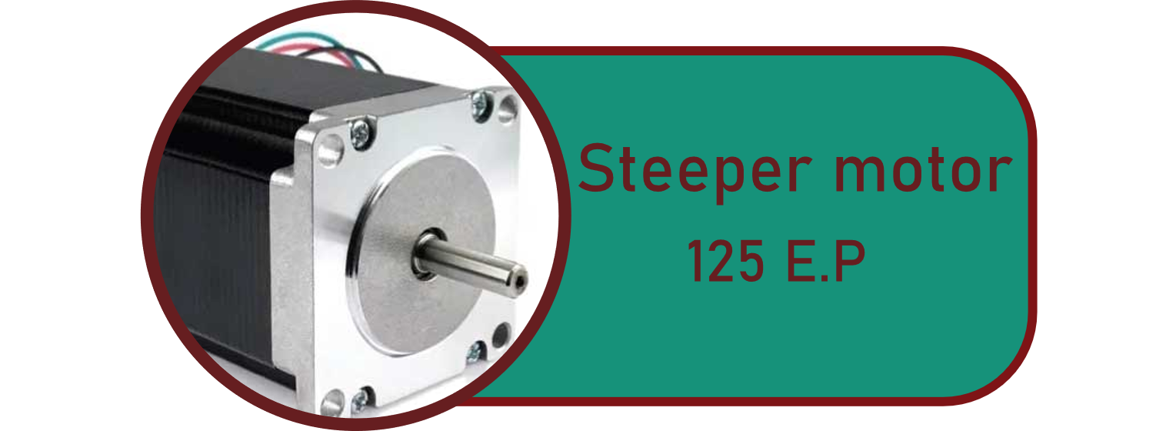
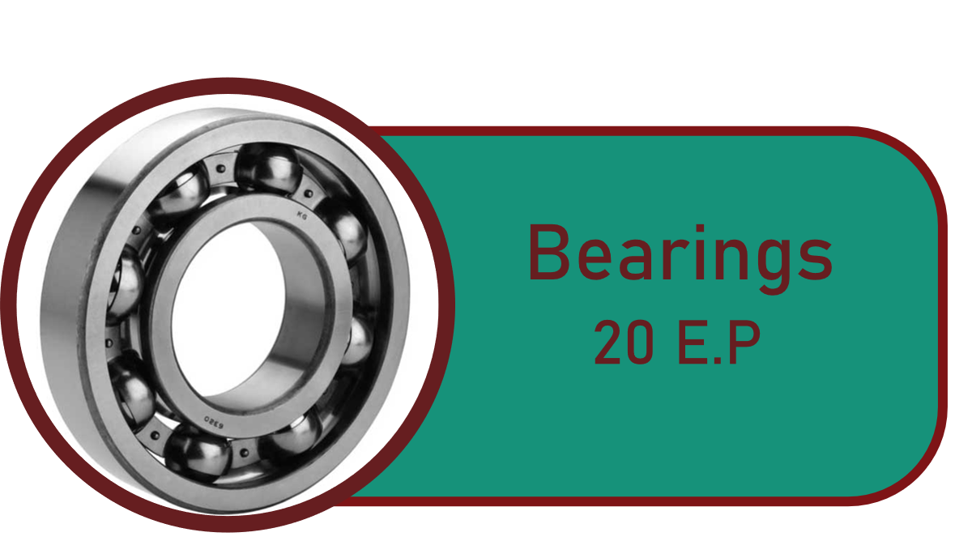
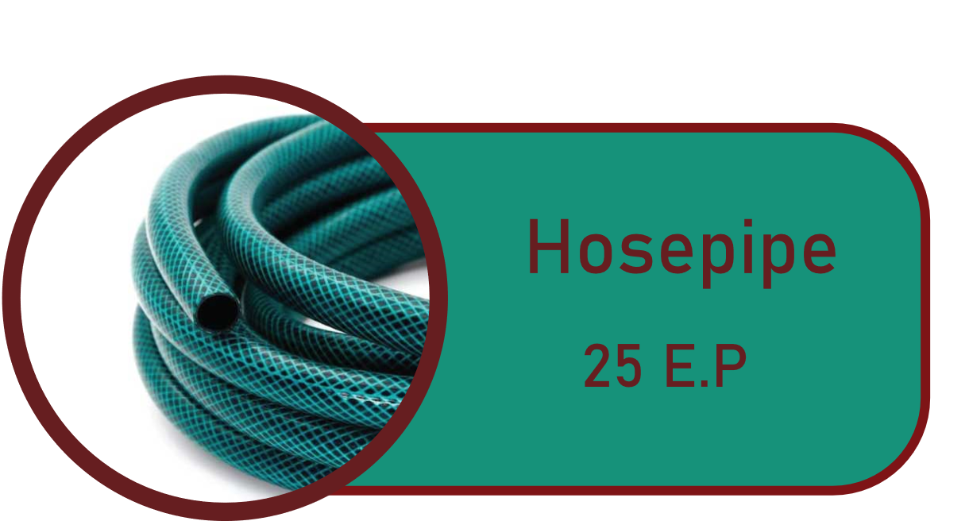
Materials:
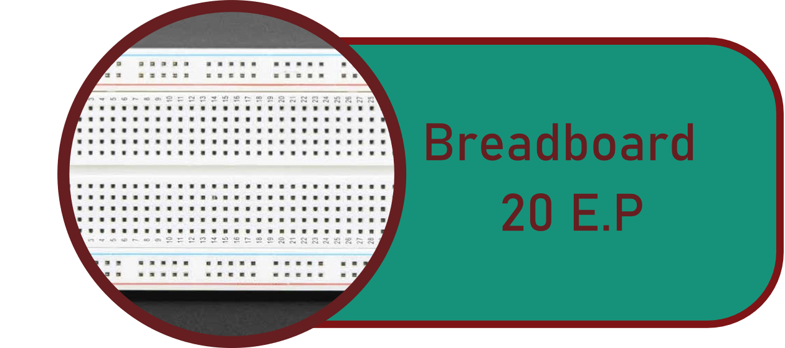
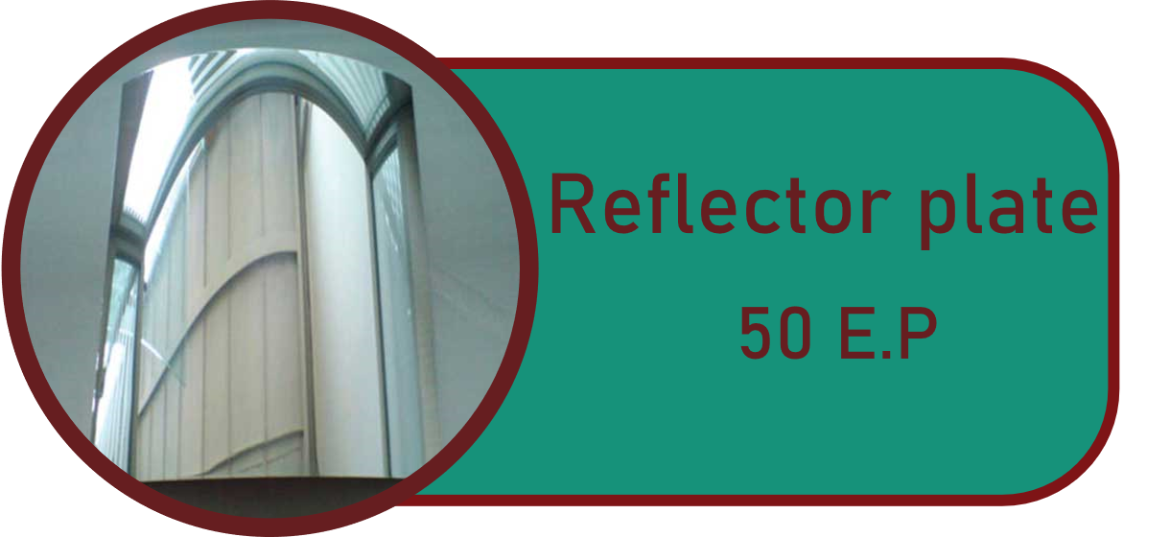
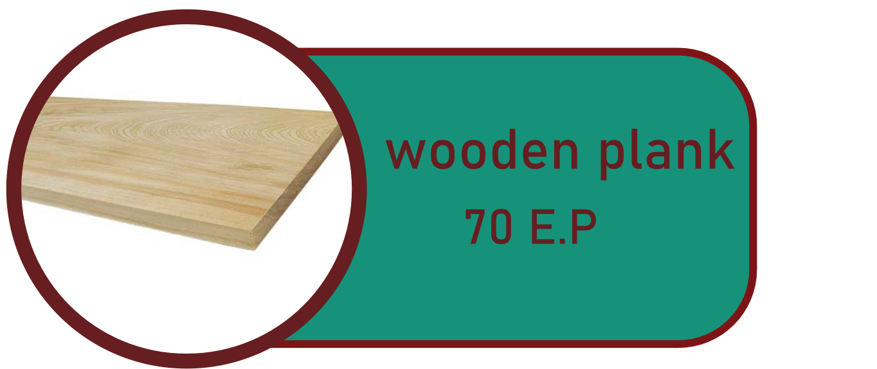
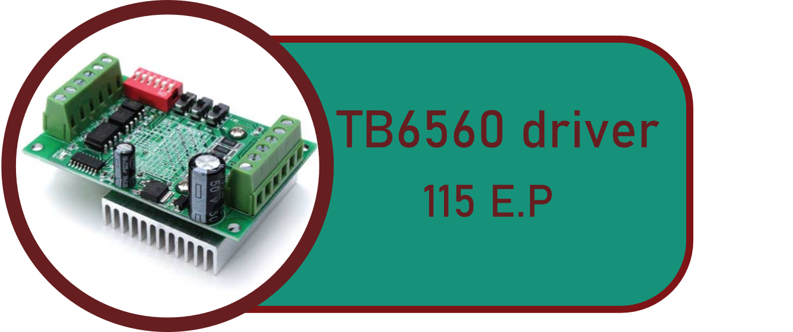
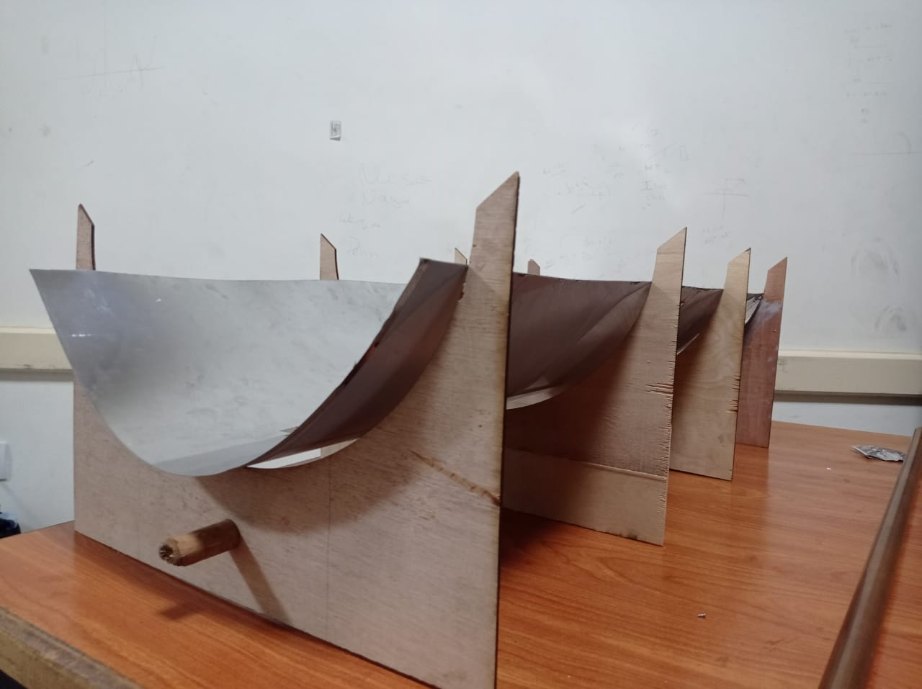
Methods:
1. It started by cutting the wood and forming the bases that the reflector will be fixed on with dimensions of 30 cm for the length and 50 cm and have cut half-circular shape with a diameter of 40 cm.
2. A circular hole was made in the bottom of each base on the half of it and at a length of 10 cm and put the wooden stick in it to work as an axis for the prototype to be rotated on, as shown in figure (1).
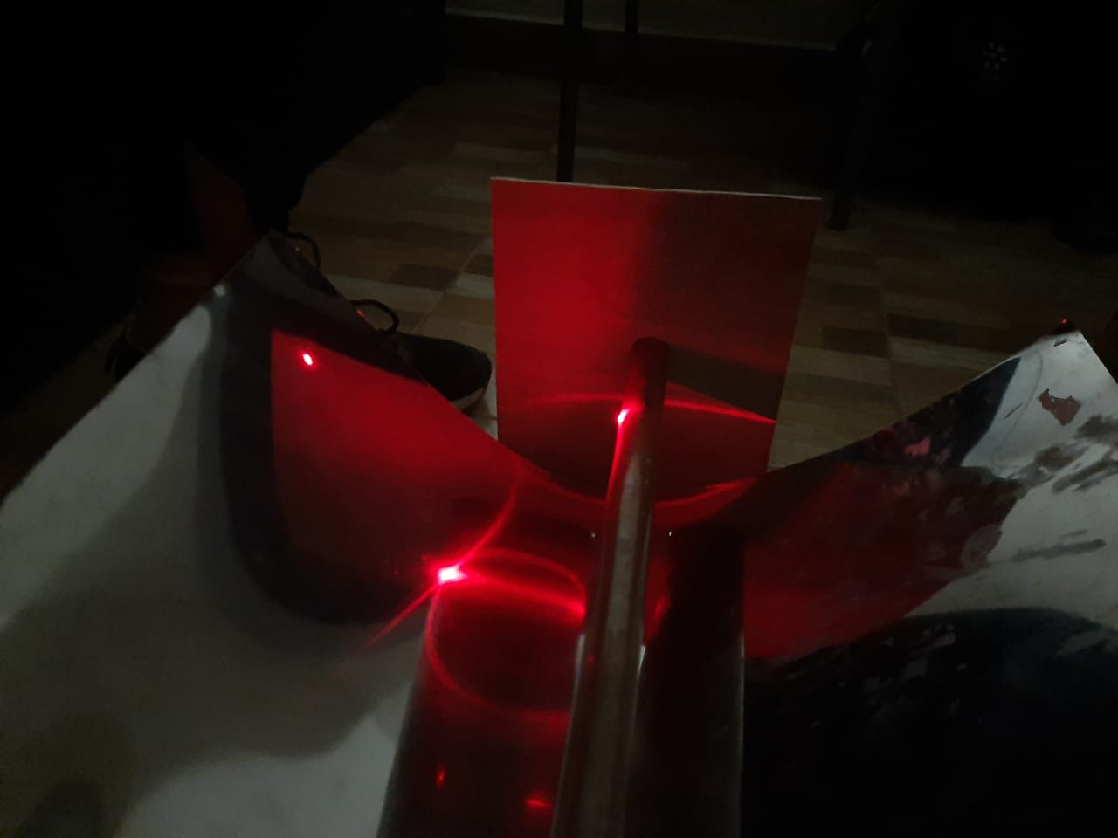
3. The reflector plate was fixed on the bases and calculating the focus of the surface also a test was made to make sure that the place of the focus is correct by using laser by focusing it on the reflecting plate from many directions and making sure that the laser reflection from all the points meeting on the focus point as shown in figure (2).
Figure (1): The prototype

4. Making an outer body for the bases from wood and making two wood parts on the beginning and the end of the reflecting surface and making a hole in them at 6.5 cm height from the surface (which is the focus point) and fixing the copper pipe in it.
Figure (2): adjustment of the focus

5. Attaching the hosepipe to the copper pipe from its two ends and connecting it with the pump
6. Putting the pump in the plastic bottle (which works as a container) and making a hole in the bottle to connect the other end of the hosepipe to the bottle
7. Connecting the pump with a 12-volt adaptor then connecting both to the relay
8. Connecting the relay to the breadboard, which is connected to Arduino UNO, also connecting the Bluetooth to the board and then opening the Arduino software and started writing the code for the pump
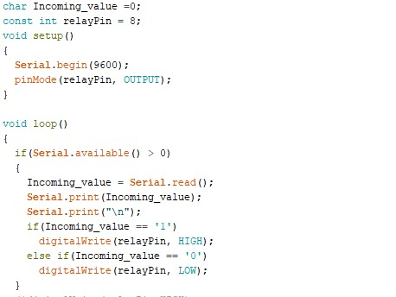
9. Building a code for the pump that makes it work if it received "1" and stop if it received "0" from the Bluetooth module as shown in figure (3).
10. The stepper motor would be attached to the axis from one end and the other attaching the bearings.
11. Connecting the stepper to the driver after that using the cables to connect the driver to the breadboard, which is connected to the Arduino UNO
12. Building a code for the stepper motor using Arduino software works according to sunrise and sunset, and it works to calculate the angle taken by the sun every hour to move the stepper motor work on this data.
Figure (3): code for pump switching.


13. Building a sample mobile app using the MIT App inventor program has two buttons on and off; when clicking on it sends "1" to the Bluetooth module and then click off, it sends "0" to it. Also, it has another part with a picking list where the user can pick the day's date and send it to the Bluetooth module as shown in figure (4).
Figure (4): mobile application interface.

Test Plan:
There are main two test plans that have been done; in the first one, the prototype was fixed, did not contain a tracing system, on the surface in the north direction, the prototype takes a long time until it reached 10 degrees difference from. In the second test plan, the prototype was connected to the stepper motor, that make it able to move to trace the sun’s direction, the prototype was settled by an angle of 30.22 to the south which is Obour city's latitude, this test was held at 12 AM with a temperature of 17°c, at which reached 10 degrees difference in temperature, which took less time compared to the first trial.

Results:
In the first trial, the weather wasn’t good, and the system was fixed so, the water only reached a difference of 10℃ in 15 minutes which gave a negative result with low efficiency.
After correcting the mistakes that are done in the first trial, on the contrary, in the second trial, there was a tracing system as the intensity of sunlight on that day was good in latitude angle of Obour city which is 30.33 to the south. In the end, the test results in a day’s temperature of 17°C, could achieve a difference of 10 degrees in only seven minutes, as shown in the graph (1). The second test plan produce approximately 28 kilojoules.

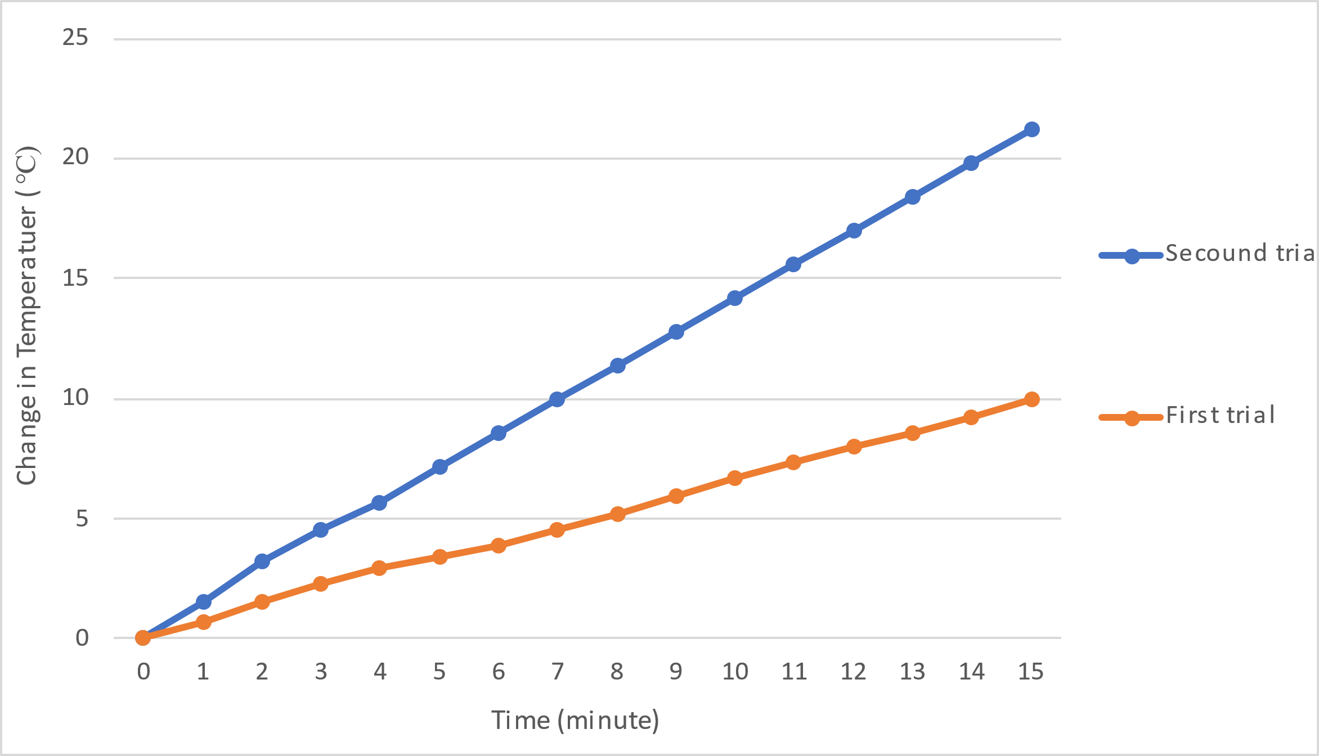
Graph (1): difference between the two trials.

Analysis:
According to the vision of Egypt in 2030 for the expansion in alternative energy production as in the current time, the major challenge is addressing how this section can be exploited in the future. Suppose the alternative energy’s problem is solved. In that case, it will decrease the pollution rates that occur because of fossil fuel usage and provide a power source that will not run out at an affordable price; however, the continued dependence on the traditional energy resources will cause a rising in the emissions of greenhouse gases. By summing up all of the information after a chain of researches is done, the applied solution, the parabolic trough, is involved in the heat’s collection energy by the reflection of the sun rays from the reflector plate to the specific point (the focal point) at which the heated fluid would be able to be stored in a container in a closed system meaning that the liquid will continue returning to the collector to be heated again and be used in viral facilities and manufacturing.
The prototype demonstrates that it is capable of meeting the specified design requirements. As well as the prototype testing and the design requirements are consistent. The first design requirement is calculating the mass flow rate, which initiates fluid speed motion in the pipe as velocity is inversely proportional to the cross-sectional area. Second, the efficiency as a requirement was modified by using a stepper motor to trace the sunlight with an array that will depend on the coordinates of the sun radiation intensity for the daytime along the latitudes as in graph (2) and using a reflector plate instead of the concave mirror that costs less in the development of the prototype. Hence, the final efficiency of the whole system is calculated by using [(𝑻_𝟐−𝑻_𝟏)/𝑻_𝟏 ∗𝟏𝟎𝟎] that will range from 50% to 70% depending on the weather’s conditions.
Graph (2): Solar intensity during the day
In order to increase the efficiency of collecting the sunlight done by the reflector plate, the parabolic trough system will be able to move in coordinates controlled by a stepper motor that would move the parabola towards the direction of the sun where the mobile app will trigger the stepper motor. By comparing the stepper motor to the servomotor, the stepper motor is more efficient in generating holding torque at low speed. The second communication method is switching the pump manually from the app. After applying these features and doing the test plan, the test plan was done in bad weather conditions. The day’s overall temperature was 17°c, the wind speed was 24 km/h, the pressure was 1016 bar, and the humidity was 47%.
Then a 19.2°c water was added to the tube and leaving the parabolic trough for seven minutes facing the sun, it could achieve 10 degrees difference seven minutes as the outcome water levels a temperature of 29.2°c, this out coming water will go to settle down in the container.
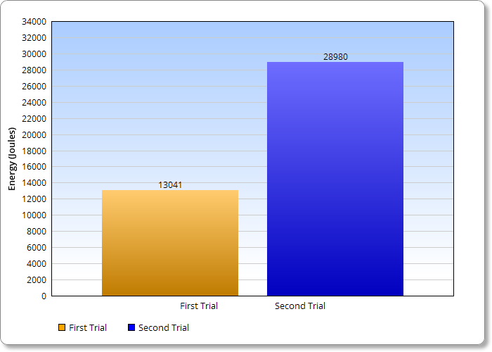
According to the done test plans as shown in graph (3), the first test plan, the negative result that didn’t achieve the chosen design requirements, only produced 13041 joules, on the other hand. The second test plan, the positive result, produced energy estimated by 28980 joules as indicated. By applying the project in real life with an area of 50 m2, by making a ratio between the area and the produced energy from the prototype, it generated approximately 2898 kilojoules.
Graph (3): Trials’ Energy

Moreover, the law that used in applying the optimum mass flow rate $\dot{(m})$ = 𝝆.𝑨.𝑽, where 𝝆 is the density of the fluid, 𝑨 is the area of the tube, and 𝑽 is the velocity in which the fluid moves with all of that will be calculated by neglecting the friction losses that at the boundaries. Consequently, by using water as the primary fluid in the prototype, and the circular area of the pipe and the hose at which the difference in the diameter will be neglected as the diameter for both would be estimated by 0.02 meters, as the total $\dot{m}$ is equal to 0.03 kg/s, so the water pump power intensity is selected in order to be able to fill all of the system with the proper amount of water in only 23 seconds. Then, to calculate total produced heat energy ($Q)=m. Cp. ΔT$, where 𝑚 is the mass flow rate, 𝑪𝒑 is the specific heat capacity, 𝒎 is the mass of the liquid, and 𝜟𝑻 is the difference in the temperature between the output temperature and the input temperature.
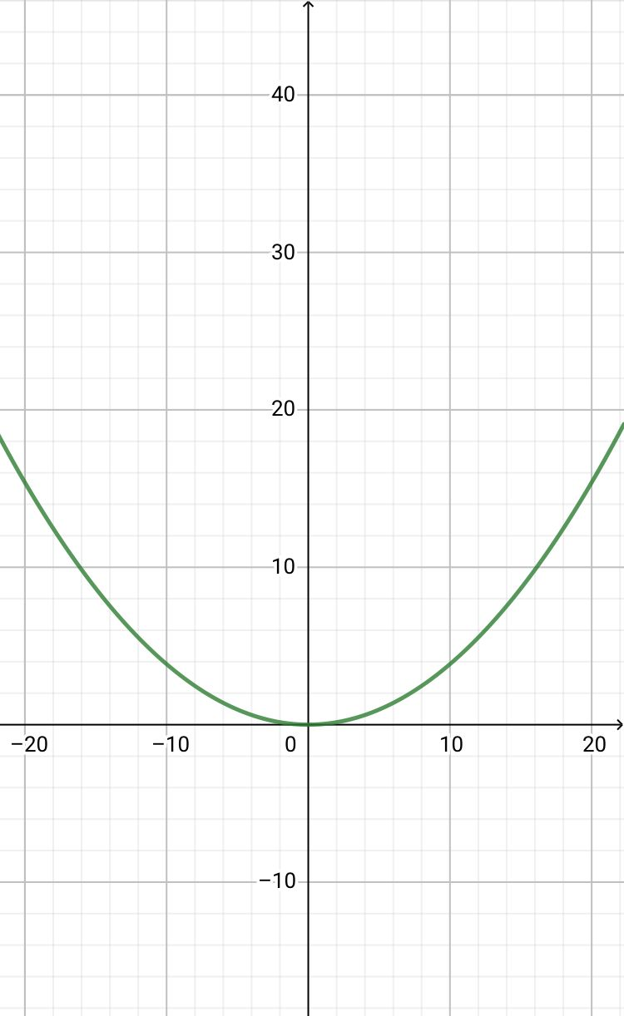
All of the energy will be equal to 28980 joules. By concluding the previous information, the fluid flow inside the system is considered laminar flow as the Reynolds number is less than 2300. Finally, for the calculation of the location of the focus, the used law is$x^{2}=4fy$as the coordinates of the x-axis is 0.40 meters, and the y-axis is 0.145 meters so that the focal length will be 0.065 meters as the function of it is presented in graph (4).
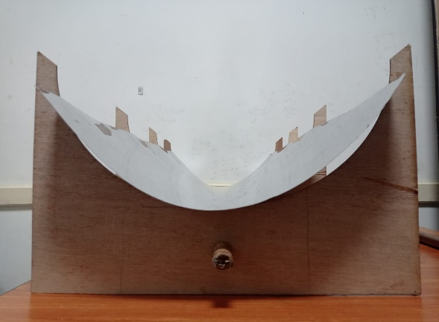

Figure (5): Constructed parabola
Graph (4): Function of the Parabola

Learning Transfer:
Biology LO 1: It showed methods of communication as the structural unit of the brain, the neuron and how it can communicate with another neuron, and there are specific regions in the brain that works as a relay center for all of the incoming signals and points it towards the target location.
Physics LO 3: One of the most underlying subjects refers to the reflection of lights and how this project can be applied with the concave mirror, in which all of the lights reflect fall on the mirror reflect and concentrate on the focal point.
Physics LO4: The other one refers to different methods of communication, even wireless communication or wired ones. It shows how wireless communication can be applied in the current project.
Math LO 1: it refers to the implicant functions, which are functions defined by an implicit equation that connects one of the factors, referred to be the function’s value, with others, referred to this as the factors. For example, the circular formula is $x^{2}+y^{2}-1=0$ that characterizes y as an implicit function of x when −1≤ x ≤1, and one confines y to nonnegative integers. We used this to specify the length of the prototype’s focus, which is $x^{2}=4fy$ (f is the position of the focus on the y axis).
Chemistry LO 1: Points out the correct scientific methods that are important for the organization of the research paths for the proper solution that can solve the problem scientifically and indicates the difference between hypothesis and theory as a hypothesis is the testable prediction that arrives logically from a theory

Conclusion:
After we got our results, we concluded that we were able to increase the temperature of the water by collecting the heat energy from the sun by 10°c in only seven minutes with efficiency 52%. Also, we were able to reach the continuity for our project as we were able to build a tracing system on moving with the sun without the need for any light sensor, which was used in the previous solar panel projects. The light sensor can be less efficient because it can be distracted by any other light source. However, in our tracing system, it was different because it depends on adding data to an Arduino system that is needed to move the stepper motor with the angle that is needed to keep tracking the sun. Also, we used a pump. We connected it with the Arduino to move the water in the system when needed. Finally, the heat energy collected in a fluid could be used in many different ways as generating electricity or in any industry that needs heat in its processes as a source of heat.

Recommendations:
Despite all the limitations we faced, our prototype succeeded in reaching our goal of improving the design of the parabolic trough to make it more efficient and make it more continuous by using modern technology like communication technology. We encountered some limitations that, unfortunately, we could not overcome problems, so we recommend that future researchers:
- Researching on using molten salt in the large-scale parabolic trough's power cells to work instead of water because it needs at least 500 degrees Celsius to be melted and can store the heat energy inside of it for up to 7 hours
- On a large scale, future researchers could connect to a climate center to provide the parabolic trough with the needed data and angles to make the tracing system work more accurate.
- Provide the project with thermal insulation materials to maintain the water or fluid temperature in the system and prevent any energy loss that can occur in the system. materials as mineral wool, cellulose and fiberglass are practical examples of thermal insulation materials that we can use in the system
- The best replacement for the water as fluid is molten salt, nanofluids, or oil, as they have more heat capacity than the water and do not lose heat faster.
- providing thermal insulation containers to transport the heated fluid to any organization that will need this fluid is essential the large-scale
- As a large-scale project, safety is a property that should be considered; thus, researchers can use more than one water temperature sensor to read the difference between them and detect the fluid's temperature with higher accuracy. This procedure will increase the project's safety by closing the system and the water flow if the fluid temperature becomes too high to handle by the pipes. So, they can explode and cause damages to the system

Citation:
-Concentration with a parabolic reflector. 2.4 Concentration with a Parabolic Reflector | EME 812: Utility Solar Power and Concentration. (n.d.). Retrieved November 29, 2021.
https://www.e-education.psu.edu/eme812/node/557
-Gama, A., Larbes, C., Malek, A., Yettou, F., & Adouane, B. (2013). Design and realization of a novel sun tracking system with absorber displacement for parabolic trough collectors. Journal of Renewable and sustainable energy, 5(3), 033108.
https://doi.org/10.1063/1.4807476
-GREENPOWERSCIENCE, (2010, October 22). DIY Parabolic Trough Mirror made in 20 minutes Stainless Steel Mirror free energy from the sun. [Video File].
https://www.youtube.com/watch?v=St-0HWKAY4k
-Halliday, D., Resnick, R., & Walker, J. (2013). Fundamentals of physics. John Wiley & Sons.
-Hamidi, S. T., Fattah, F. A., & Ghanam, M. S. (2018). Performance Improvement of the Parabolic Trough Solar Collector Using Different Types of Fluids with Numerical Simulation. Journal of University of Babylon for Engineering Sciences, 26(6), 332-347.
https://doi.org/10.29196/jubes.v26i6.1437.

Acknowledgment:
This work could not have been possible without the crucial help of Dr.Essam El-sayed from NREA ( New and Renewable Energy Authority) and his crew. Also big thanks to Mr. Faisal Abo-eleinen and Mr. gad El-rab for helping us In the constructing prototype process. We mostly thank the School principal and the capstone teachers who helped us to have the final project successfully.

For further information:
Yousef Ahmed: yousef.2119071@stemkalubya.moe.edu.eg
Mohamed Haitham: moahmed.2119062@stemkalubya.moe.edu.eg
Ramy Said: ramy.2119024@stemkalubya.moe.edu.eg

